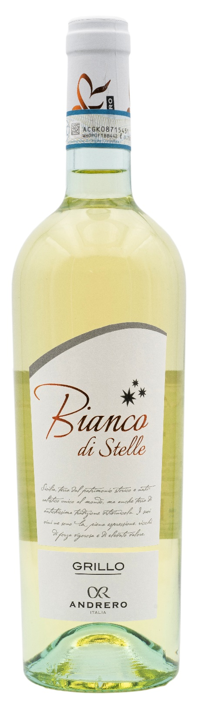
GRILLO DOP – BIANCO DI STELLE

Grape: Grillo 100%
Alc. Vol.%: 12,5
Vintage: 2025
Residual sugar g/l: 4,0
Total acidity g/l: 6,0
Region: Sicily
Production zone: Vineyards in the province of Trapani
Capacity: 750ml

CHARACTERISTICS

Vinification: Cold fermentation in steel tanks
Yield per ha: 12000kg
Colour: Bright straw-yellow with greenish reflections
Bouquet: Fresh, with interesting notes of citrus, fruits and rosemary
Flavour: Smooth, structured, and fresh

SERVING SUGGESTIONS

Best enjoyed with fish, soups, and white meat.
Serving temperature 8 °C
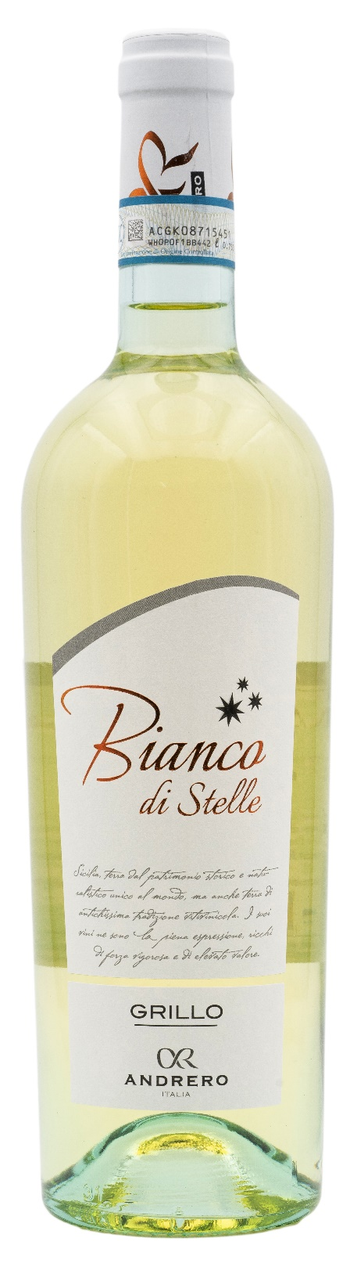
TECHNICAL INFORMATION / PALLETIZING

Size 750ml:
Article Nr. V01019A
GTIN-13 bottle 8017868003854
GTIN-13 carton 8017868004769
Closure Cork
Bottles / carton 6 bottles
Pallet size 80x120cm
Cartons/layer 21
Cartons/pallet 105
Kg/carton 7,8
Kg/pallet 840

Contains sulphites
GMO Free
Revisione 01. 21.04.2026

