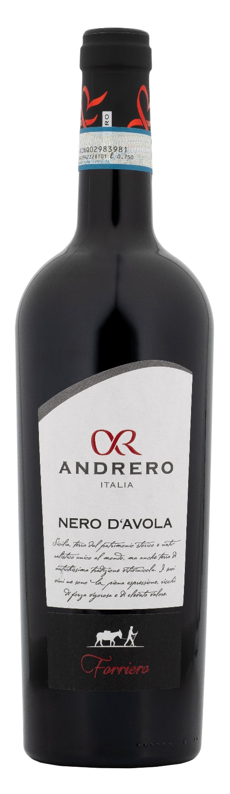
NERO D’AVOLA DOP – FORRIERO

Grape: Nero d’Avola 100%
Alc. Vol.%: 14
Vintage: 2024
Residual sugar g/l: 6,6
Total acidity g/l: 5,4
Region: Sicily
Production zone: Vineyards in the province of Trapani
Capacity: 750ml

CHARACTERISTICS

Vinification: In steel tanks at a controlled temperature for 10 days of peel maceration
Aging: After the malolactic fermentation, the wine is conserved for 8 months in steel tanks
Yield per ha: 12000kg
Colour: Intense red with violet reflections
Bouquet: Intense aromas of wild berries
Flavour: Elegant, balanced and full bodied, with a smooth and velvety finish

SERVING SUGGESTIONS

Best enjoyed with spicy pasta, red meat and cheese.
Serving temperature 16-18 °C
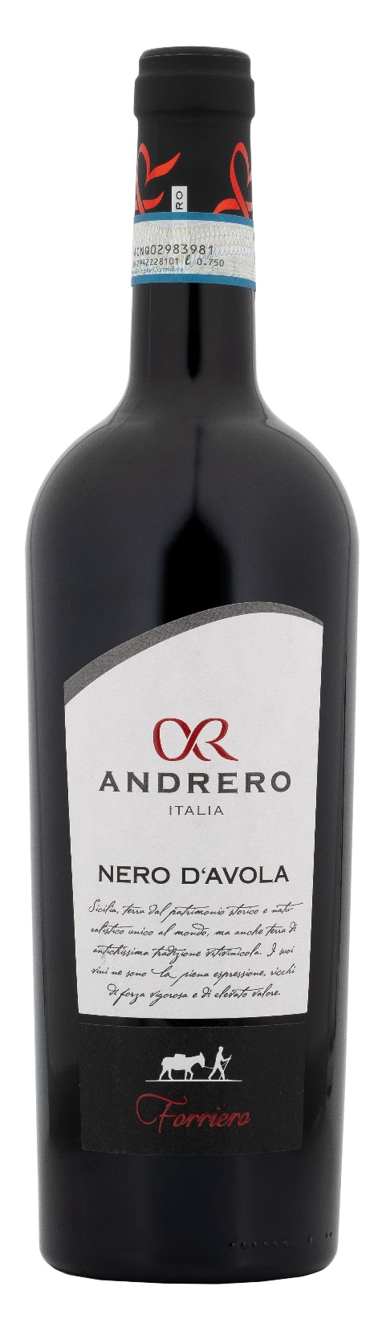
TECHNICAL INFORMATION / PALLETIZING

Size 750ml:
Article Nr. V01003A
GTIN-13 bottle 8017868000303
GTIN-13 carton 8017868004172
Closure Cork
Bottles / carton 6 bottles
Pallet size 80x120cm
Cartons/layer 21
Cartons/pallet 105
Kg/carton 7,8
Kg/pallet 840

Contains sulphites
GMO Free
Revisione 01. 21.04.2026

