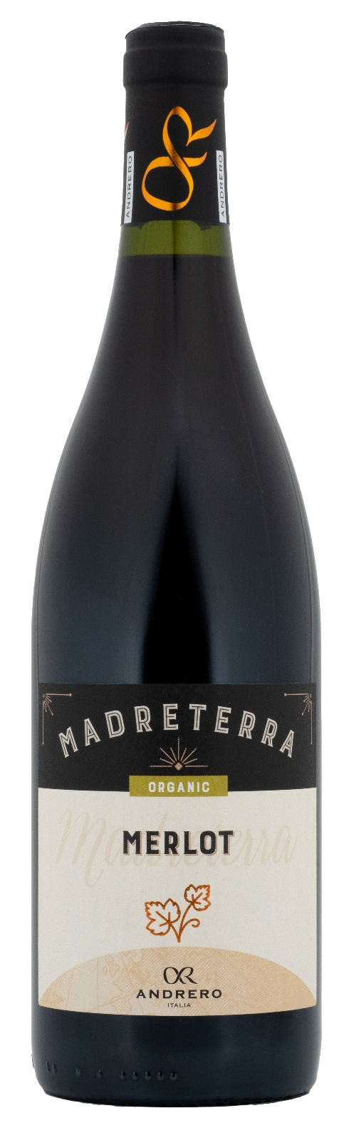
MERLOT IGP ORGANIC – MADRETERRA

Grape: Merlot 100%
Alc. Vol.%: 14,5
Vintage: 2022
Residual sugar g/l: 4,9
Total acidity g/l: 5,4
Region: Sicily
Production zone: Vineyards in the area of Fauma / Realmonte - Province of Agrigento - Sicily
Capacity: 750ml

CHARACTERISTICS

Vinification: In steel tanks at a controlled temperature
Aging: At least 6 months in steel
Yield per ha: 12000kg
Colour: Deep and brilliant red
Bouquet: Fruity and deep with elegant notes of plums and spices
Flavour: Warm and complex with a long-lasting finish

SERVING SUGGESTIONS

Best enjoyed with savoury starters, cold cuts and grilled meat.
Serving temperature 18 °C
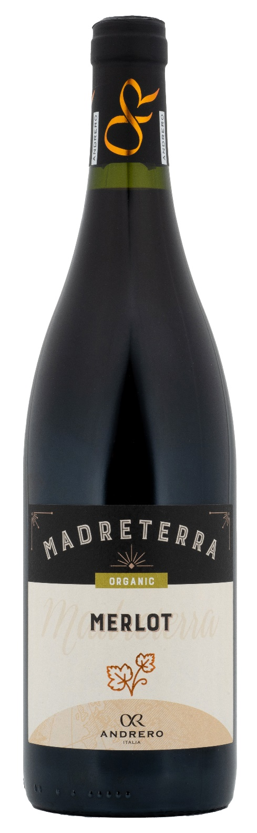
TECHNICAL INFORMATION / PALLETIZING

Size 750ml:
Article Nr. V01027A
GTIN-13 bottle 8017868001683
GTIN-13 carton 8017868001607
Closure Cork
Bottles / carton 6 bottles
Pallet size 80x120cm
Cartons/layer 21
Cartons/pallet 105
Kg/carton 7,2
Kg/pallet 775

Contains sulphites
GMO Free
Revisione 01. 06.02.2024

