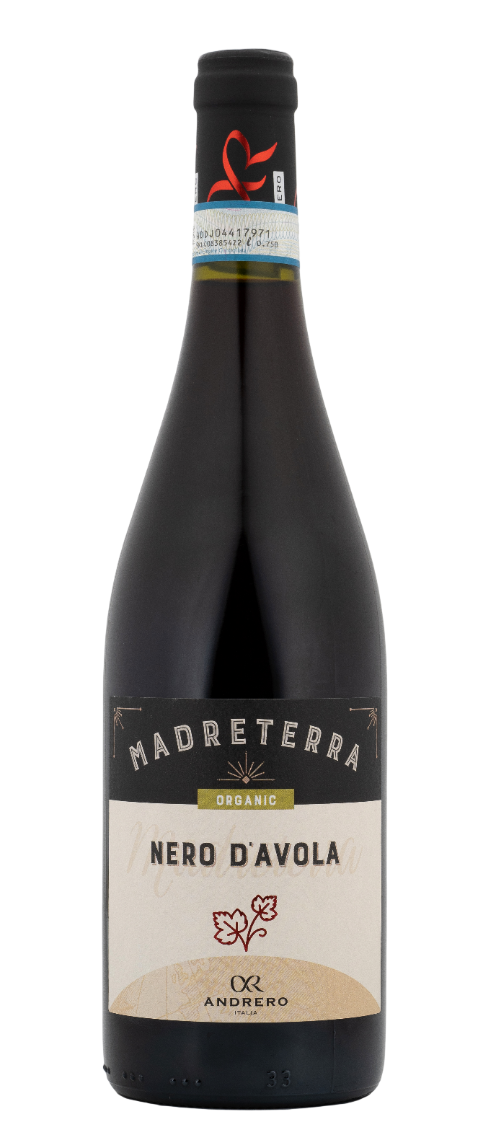
NERO D’AVOLA DOP ORGANIC – MADRETERRA

Grape: Nero d’Avola 100%
Alc. Vol.%: 14
Vintage: 2022
Residual sugar g/l: 6,0
Total acidity g/l: 5,6
Region: Sicily
Production zone: Vineyards in the area of Fauma / Realmonte - Province of Agrigento - Sicily
Capacity: 750ml

CHARACTERISTICS

Vinification: In steel tanks
Aging: After the malolactic fermentation, the wine is aged in steel tanks for about 6 months
Yield per ha: 12000kg
Colour: Bright red with purple reflections
Bouquet: Clear hints of berries and currant
Flavour: Balanced and firm, fruity and harmonious

SERVING SUGGESTIONS

Savory pasta dishes, grilled red and white meats.
Serving temperature 16-18 °C
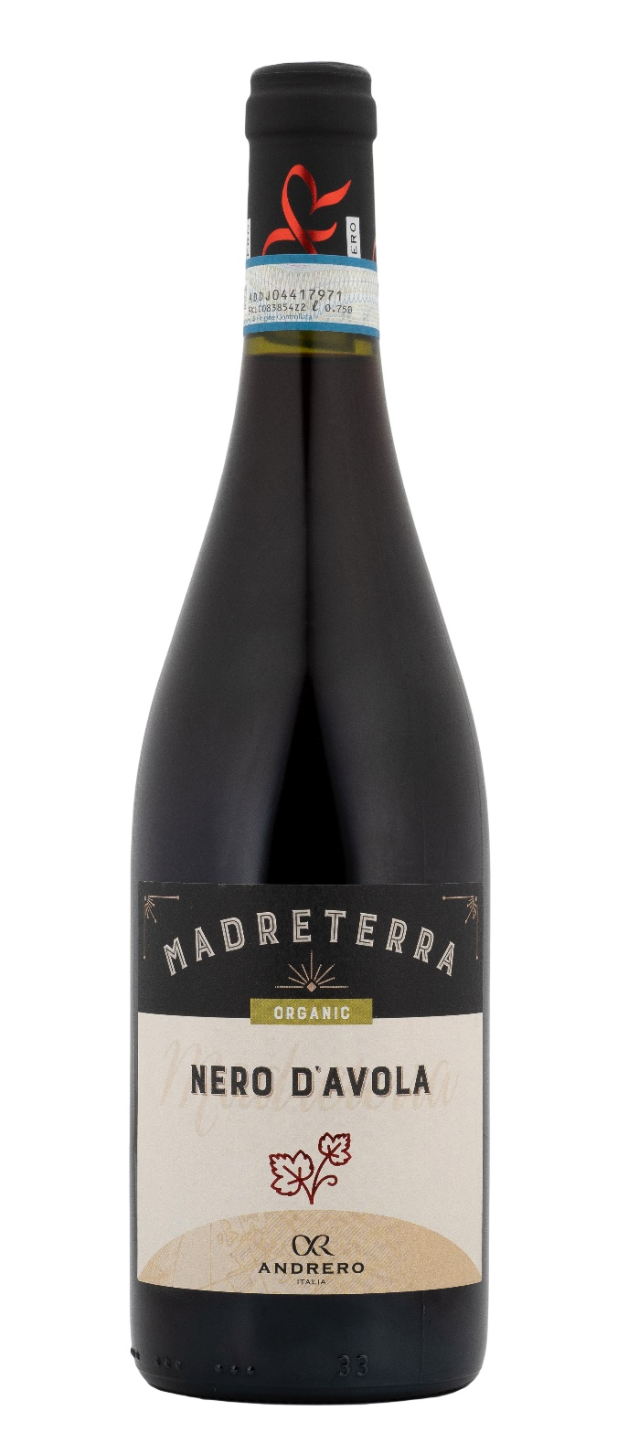
TECHNICAL INFORMATION / PALLETIZING

Size 750ml:
Article Nr. V01012A
GTIN-13 bottle 8017868001034
GTIN-13 carton 8017868001232
Closure Cork
Bottles / carton 6 bottles
Pallet size 80x120cm
Cartons/layer 21
Cartons/pallet 105
Kg/carton 7,2
Kg/pallet 775

Contains sulphites
GMO Free
Revisione 01. 06.02.2024

