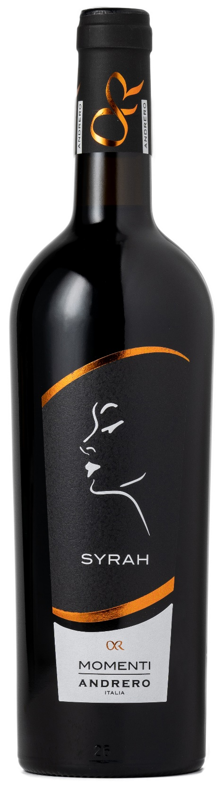
SYRAH IGP – MOMENTI

Grape: Syrah 100%
Alc. Vol.%: 14,5
Vintage: 2023
Residual sugar g/l: 8,0
Total acidity g/l: 5,5
Region: Sicily
Production zone: Vineyards in the province of Trapani
Capacity: 750ml

CHARACTERISTICS

Vinification: In steel tanks at a controlled temperature
Aging: At least 6 months in stainless steel
Yield per ha: 14000kg
Colour: Intensive red with purple reflections
Bouquet: Pleasant notes of wild berries and violets
Flavour: Full-bodied and deep, round and smooth on the finish

SERVING SUGGESTIONS

Best enjoyed with stewed meat, venison and spicy cheese.
Serving temperature 18 °C
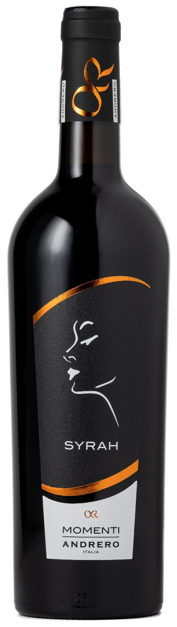
TECHNICAL INFORMATION / PALLETIZING

Size 750ml:
Article Nr. V01009A
GTIN-13 bottle 8017868001362
GTIN-13 carton 8017868001379
Closure Cork
Bottles / carton 6 bottles
Pallet size 80x120cm
Cartons/layer 21
Cartons/pallet 105
Kg/carton 7,8
Kg/pallet 840

Contains sulphites
GMO Free
Revisione 01. 06.02.2024

