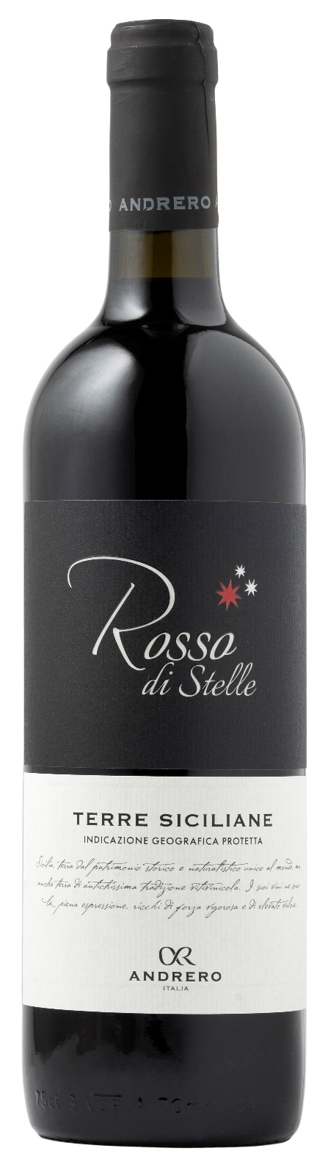
ROSSO TERRE SICILIANE IGP – ROSSO DI STELLE

Grape: Mainly Syrah, Merlot
Alc. Vol.%: 13
Vintage: 2024
Residual sugar g/l: 7,0
Total acidity g/l: 5,5
Region: Sicily
Production zone: Vineyards in the Province of Trapani
Capacity: 750ml

CHARACTERISTICS

Vinification: Traditional peel-maceration at a controlled temperature
Aging: In stainless steel
Yield per ha: 14000kg
Colour: Intense and shiny red
Bouquet: Fruity and rich
Flavour: Soft, round and harmonic

SERVING SUGGESTIONS

Excellent with starters, first courses and red meat.
Serving temperature 16-18 °C
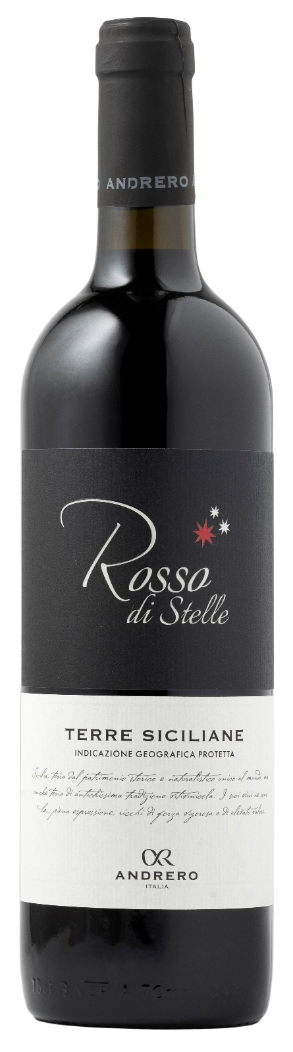
TECHNICAL INFORMATION / PALLETIZING

Size 750ml:
Article Nr. V01013A
GTIN-13 bottle 8017868004813
GTIN-13 carton 8017868004820
Closure Cork
Bottles / carton 6 bottles
Pallet size 80x120cm
Cartons/layer 25
Cartons/pallet 125
Kg/carton 6,9
Kg/pallet 880

Contains sulphites
GMO Free
Revisione 01. 21.04.2026

