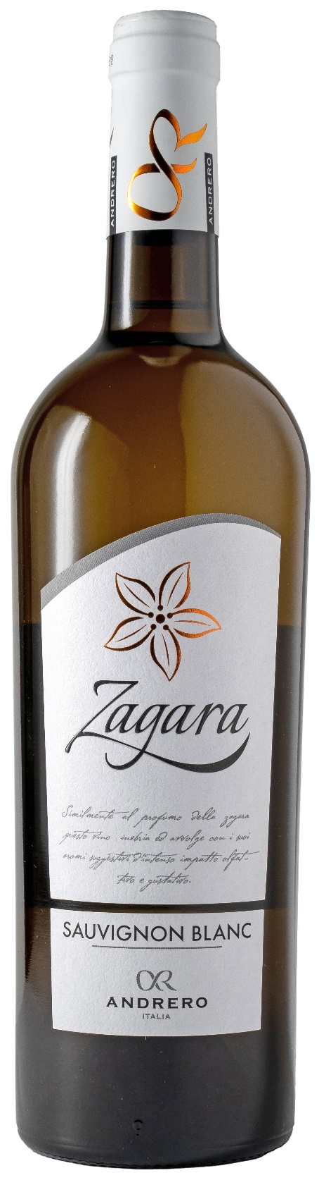
SAUVIGNON BLANC IGP – ZAGARA

Grape: Sauvignon Blanc 100%
Alc. Vol.%: 13
Vintage: 2025
Residual sugar g/l: 4,0
Total acidity g/l: 5,6
Region: Sicily
Production zone: Vineyards in the province of Trapani
Capacity: 750ml

CHARACTERISTICS

Vinification: Cold fermentation in steel tanks
Yield per ha: 14000kg
Colour: Greenish yellow
Bouquet: Fresh with elegant notes of fresh herbs, such as sage and tropical fruits
Flavour: An elegant minerality is combined with balanced flavours of peach and tropical fruits

SERVING SUGGESTIONS

Best enjoyed with fish dishes, fresh cheese and poultry.
Serving temperature 8 °C
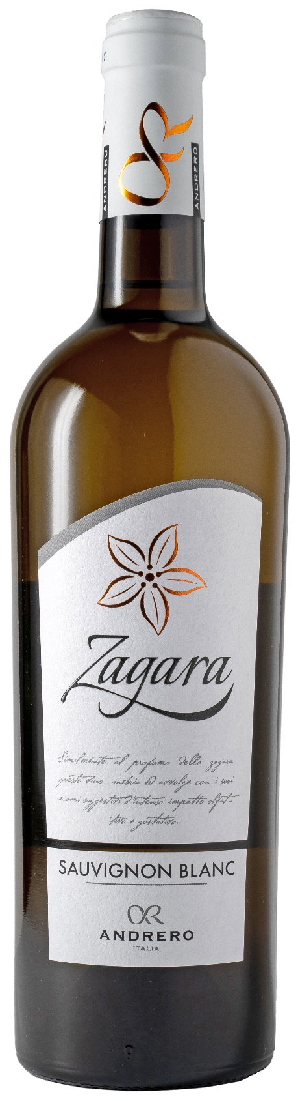
TECHNICAL INFORMATION / PALLETIZING

Size 750ml:
Article Nr. V01016A
GTIN-13 bottle 8017868002734
GTIN-13 carton 8017868002741
Closure Cork
Bottles / carton 6 bottles
Pallet size 80x120cm
Cartons/layer 21
Cartons/pallet 105
Kg/carton 7,8
Kg/pallet 840

Contains sulphites
GMO Free
Revisione 01. 21.04.2026

